**COLLEGE OF TECHNOLOGY**

**COIMBATORE-641004**



**EMBEDDED SYSTEMS LABORATORY-(15Z610)**

**COLOR SORTER MACHINE**

**COMPUTER SCIENCE AND ENGINEERING**

**TEAM MEMBERS :**

**S.V.UDHAYAN (17Z356)**

**S.ASHOK KUMAR (18Z463)**

**R.S.KAMALAKKANNAN (18Z467)**

**S.PRAVIN PRABHU(18Z471)**

**INTRODUCTION:**

color sorting is simply to sort the things according to their color. It can be easily done by seeing it .but , when there are too many things to be sorted and if it is a repetitive task , then automatic color sorting machines are very useful.

They can be used in different application areas where color identification, color distinction and color sorting is important.

Some of the application areas include Agriculture Industry (Grain Sorting on the basis of color), Food Industry, Diamond and Mining Industry, Recycling etc.

**PROBLEM STATEMENT:**

The color sorter machines are used to separate objects based on color. They have color sensor to sense the color of any objects and after detecting the color , a servo motor grab the object and put it into respective box.

**COMPONENTS REQUIRED:**

* Arduino UNO
* Colour sensor (TCS3200)
* Servo motors
* Jumpers
* Bread Board

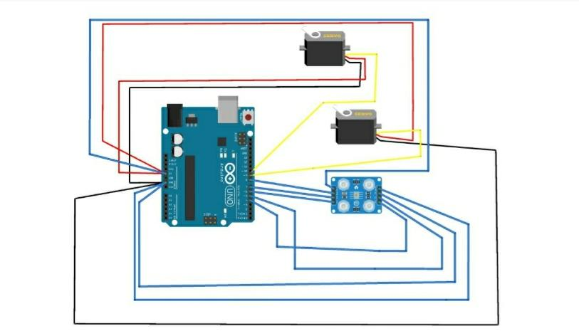**SCHEMATIC DIAGRAM:**

**CODE:**

#include <Servo.h>

Servo Servo1;

Servo Servo2;

#define S0 4

#define S1 5

#define S2 7

#define S3 6

#define sensorOut 8

int f = 0;

int color=0;

int j=0;

int detecttColor() {

// activating red photodiodes to read

digitalWrite(S2, LOW);

digitalWrite(S3, LOW);

f = pulseIn(sensorOut, LOW);

int R = f;

Serial.print("Red = ");

Serial.print(f);//printing RED color f

Serial.print(" ");

delay(50);

// activating blue photodiodes to read

digitalWrite(S2, LOW);

digitalWrite(S3, HIGH);

f = pulseIn(sensorOut, LOW);

int B = f;

Serial.print("Blue = ");

Serial.print(f);

Serial.print(" ");

// activating green photodiodes to read

digitalWrite(S2, LOW);

digitalWrite(S3, HIGH);

// Reading the output frequency

f = pulseIn(sensorOut, LOW);

int G = f;

Serial.print("Green = ");

Serial.print(f);

Serial.println(" ");

delay(50);

delay(50);

if(R<=1510 &R>=1380 & B>=0 &B<=14 & G<=495 & G>=340){

color = 1;

Serial.print("Detected Color is = ");

Serial.println("PURPLE");

}

if(R<=1290 &R>=1100 & B>=0 &B<=12 & G<=385 & G>=228){

color = 2;

Serial.print("Detected Color is = ");

Serial.println("YELLOW");

}

if(R<=1625 &R>=1511 & B>=0 &B<=10 & G<=460 & G>=340){

color = 3;

Serial.print("Detected Color is = ");

Serial.println("BLUE");

}

return color;

}

void setup() {

pinMode(S0, OUTPUT);

pinMode(S1, OUTPUT);

pinMode(S2, OUTPUT);

pinMode(S3, OUTPUT);

pinMode(sensorOut, INPUT);

//f-scaling to 20% selected

digitalWrite(S0,LOW);

digitalWrite(S1, HIGH);

Servo1.attach(9);

Servo2.attach(10);

Serial.begin(9600);

}

void loop() {

//initial position of servo motor

Servo1.write(180);

Servo2.write(0);

delay(600);

for(int i = 170; i >= 127; i--) {

Servo1.write(i);

delay(20);

}

delay(500);

//read color values by calling function. save the values for conclusion in variable

j=0;

color = detecttColor();

while(color==0)

{color = detecttColor();

j=j+1;

if(j==20)

{

color=3;

}

}

delay(1000);

switch (color) {

case 1:

Servo2.write(30);

break;

case 2:

Servo2.write(90);

break;

case 3:

break;

}

delay(500);

for(int i = 127; i > 29; i--) {

Servo1.write(i);

delay(20);

}

delay(300);

for(int i = 29; i < 115; i++) {

Servo1.write(i);

delay(20);

}

color=0;

}

**PLAGIARISM:**

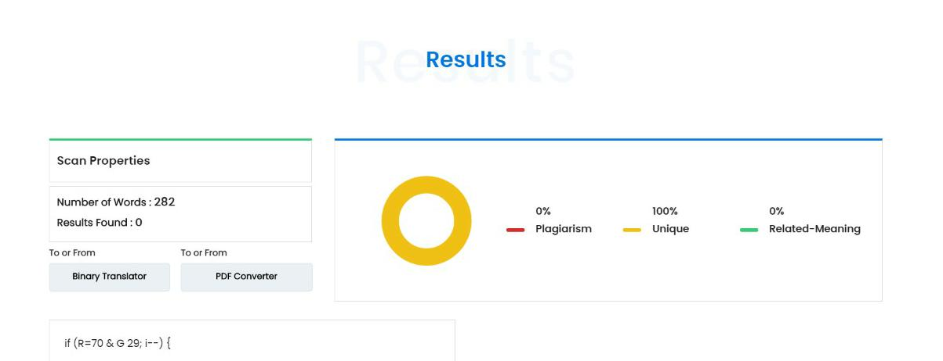

**CHALLENGES FACED:**

They can be used in different application areas where color identification, color distinction and colour sorting is important.

Some of the application areas include Agriculture Industry (Grain Sorting on the basis of color), Food Industry, Diamond and Mining Industry, Recycling etc. The applications are not limited to this and can be further applied to different industries.

Colour sorting machines are also used in the diamond industry. The transparency of the diamond is measured by the colour sorter and used as a measurement of its purity, and the diamonds are mechanically sorted accordingly. This has an advantage over X-Ray fluorescence methods of robotically detecting purity, since purer diamonds are less likely to fluoresce.

**CONTRIBUTION OF TEAM MEMBERS:**

Udhayan -code implementation

Ashok Kumar -model design

Kamalakkannan -code implementation

Pravin prabhu**-** model design

**REFERENCES:**

<https://randomnerdtutorials.com/arduino-color-sensor-tcs230-tcs3200/>

<https://www.allaboutcircuits.com/projects/servo-motor-control-with-an-arduino/>

https://github.com/ashoksanjai/Embedded_Systems_Laboratory.git